Enhancement of Interpersonal Situational Awareness via User Interface Design Improvements in Mobile Ride-Sharing Applications

Uyen Bui, David Hermoza, Gregory Mather, and Todd Roescher

California State University, Long Beach

**FEATURE AT A GLANCE:**

In this article, we present a summary of current user-interface design considerations and suggest improvements to person to person ride-sharing applications (apps). Ridesharing apps do not sufficiently transfer information in a way that carefully considers situational awareness (SA) principles and safety information. Therefore, the paper focuses on improving user interface design by employing human factors theories to increase safety outcomes. We discuss these principles with the goal of guiding future iterations of design for these apps, ameliorating user SA deficiencies in regard to the safety of the driver and riders.

**KEYWORDS:**

Mobile applications, user safety, situational awareness, user-interface, user-experience, ride-sharing, information transfer, recency, primacy, gestalt, multisensory encoding

**Introduction**

With the advent and ubiquity of smartphone technology, access to rideshare services, like Uber and Lyft, have become a mainstay of modern culture. In fact, research indicates that 36% of the United States (US) adults use ride-sharing applications (app), and approximately 14 million trips are completed daily worldwide (“Company Information: Uber”, 2019; Pew Research Center, 2019; SharesPost, 2017). Also, the once heavily regulated taxi industry has evolved into a service where the lines between provider and consumer are fluid and transient, allowing riders to easily transition to the driver (Hall, Palsson, & Price, 2018). However, with the increase in accessibility and ease of use, new issues regarding safety have emerged. In March of 2019, a 21-year old New Jersey woman was kidnapped and murdered as a result of driver-vehicle misidentification after believing the vehicle she got into was her Uber (“She thought it was her Uber. Student got into the wrong car and was killed, police say”, 2019). Another woman suffered several bodily injuries when she jumped from a speeding vehicle that pretended to be her Uber ride (Spears, 2018). According to the 2017-2018 US safety report published by Uber (2019), there were approximately 6,000 reported cases of fatal physical assaults and sexual assaults combined over the past two years. The present paper discusses the problems in design that contribute to the current dangers associated with these rideshare apps and addresses potential adjustments in the User Interface (UI) and User Experience (UX) currently in place. The goal is to offer solutions for the issues that currently plague the app, while retaining the apps ease of use.

Situational awareness (SA) consists of three stages: the perception of elements in the environment, understanding the meaning of those elements, and being able to determine the future status of those elements (Endsley, 1988). As each stage of SA contributes to each other, the user ends up with poor overall SA if the initial stages of perceiving and understanding the elements were misunderstood. Therefore, the app should ensure information is presented in a way that emphasizes the initial stages of SA.

Presently, rideshare UI/UX design focuses primarily on ease of use, which minimizes the time between the first button press and getting a ride. This focus has led to an interface that places safety as a secondary concern, as the information presented to drivers/riders is not adequately made salient and both parties do not care to properly verify the other party. Due to the lack of salience regarding critical information, there is a diminished level of SA across the board. That is to say, the driver could not be certain the rider is the correct person that should be present in the vehicle and the rider is not certain that the driver/vehicle is correct. This allows individuals with malicious intentions to exploit the lack of SA and misrepresent themselves as legitimate riders/drivers and take advantage of the rightful driver or rider.

Tweaks to the user interface of the apps through Gestalt principles, the sensation and perceptual laws by which visual cues are understood and remembered (Koffka, 1935), may allow for riders to perceive and retain important safety information with no added effort. Furthermore, as memory limits have been noted as being a significant bottleneck toward adequate SA, we will present UX/UI design considerations to address the stages of encoding, storage, and retrieval in memory (Endsley, Bolte, & Jones, 2003). We postulate that the utilization of unique sensory cues, recency and primacy effects will aid in preventing failures in memory and subsequent SA. Additionally, changes to the existing safety toolkit will increase salience for critical features while simultaneously making those features more accessible to older and color-deficient riders. Finally, we offer a new driver/rider verification system that streamlines communication between the two parties, while improving accessibility to people with certain disabilities.

Flow Diagram using the Uber application:

(a) (b) (c) (d)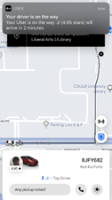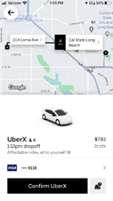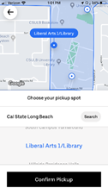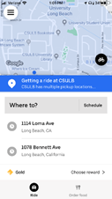

(e) (f) (g) (h)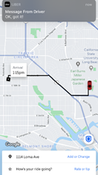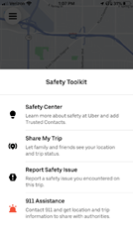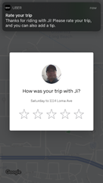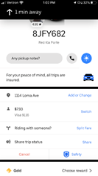

(i)

*Figure 1*. Flow chart of Uber experience. (a). Opening screen of the Uber App, (b). Uber ride confirmation screen. (c). Confirmation page. (d). Post-order screen, viewed while waiting for ride to arrive at pickup. (e). First screen shown when the trip is started, after the rider has entered the driver’s vehicle. (f). Ride information screen. (g). Safety toolkit screen. (h.) Driver review screen. (i) Post-ride review and tipping screen. The recommendations provided in this paper focus primarily on screens “e” and “g.”

**Memory Systems (Recency and Primacy, Retrieval Cues, Encoding Specificity)**

Modern theories of memory assert that the interaction of transience and persistence have been noted as contributing toward effective memory-based decisions in loud or distracting environments (Richards & Frankland, 2017). These opportunities through which Human Factors oriented design elements may be implemented to address inadequacies in memory may improve SA of critical safety information.

Recency and Primacy effects, the increased ability to retain and recall information presented either first or last and forget information in the middle (Ebbinghaus, 1885) may also allow for effortless integration of important identification information of the driver (Tan & Ward, 2000). Cognitive preference for information being presented in smaller groups (i.e. chunking) as opposed to a single longer string has been well studied (Thalmann, Souza, & Oberauer, 2019). These combined with presenting a unique salient cue, during the encoding of important safety information (e.g. license plate, driver), and recreating it in the same manner during retrieval (i.e., when the driver arrives) has been noted as a mechanism by which context specific memories are able to be retrieved more easily (Richards & Franklin, 2017; Tulving & Thomas, 1973). This unique contextual use of unique auditory/visual cues leverages encoding specificity principles to improve memory and SA (Tulving & Thomas, 1973).

When considering recency and primacy effects, it is the transience of unneeded information that makes our presentation of the unique multimodal cue potentially even more salient for persistence of memory, and subsequent SA improvements (Richards & Frankland, 2017; Bolstad, Costello & Endsley, 2006). Previous research regarding salient cues**,** note that the unique combination of visual and auditory cues allows the user to increase the efficacy of initial encoding (Tulving & Thomas, 1973).

We assert that these combined methods will lead to increased facilitation of the transfer and utilization of important information due to decreases in working memory load and subsequent allowance of more resources for encoding (Richards & Franklin, 2017).

**Gestalt Principles in Application Design**

Implementation of the Gestalt Principles in app design and deployment could facilitate a greater understanding of information from the rider’s perspective. While several Gestalt principles are already employed in the major ride sharing based apps, variation in the implementation of the principles could yield more efficient information transfer. Uber and Lyft already both utilize common region, proximity, and similarity principles in their mobile apps as seen in their safety information sections and their ride information section (Figure 2).

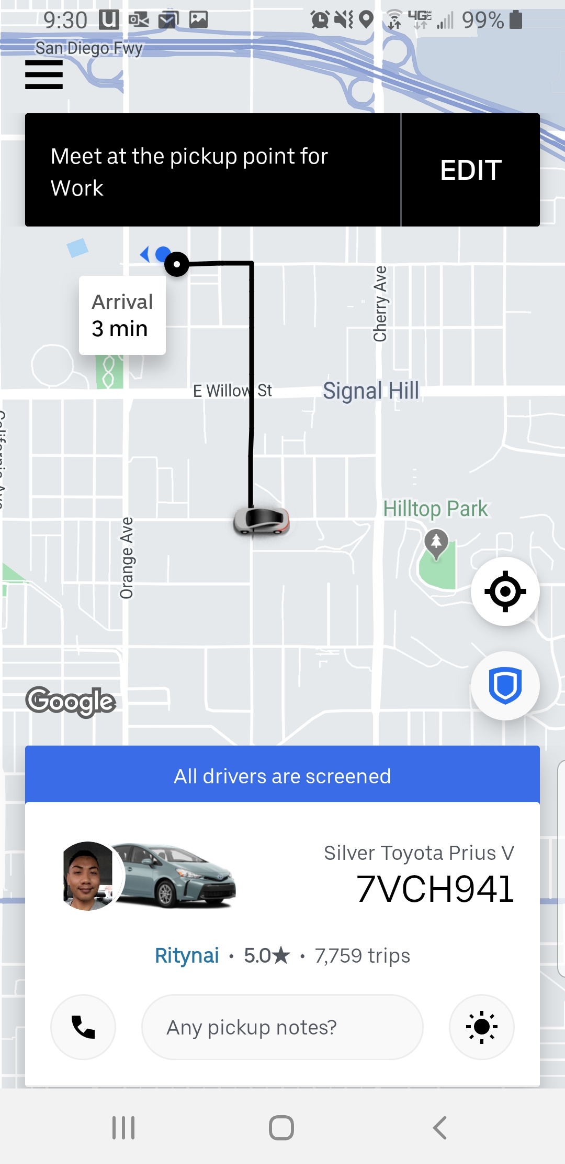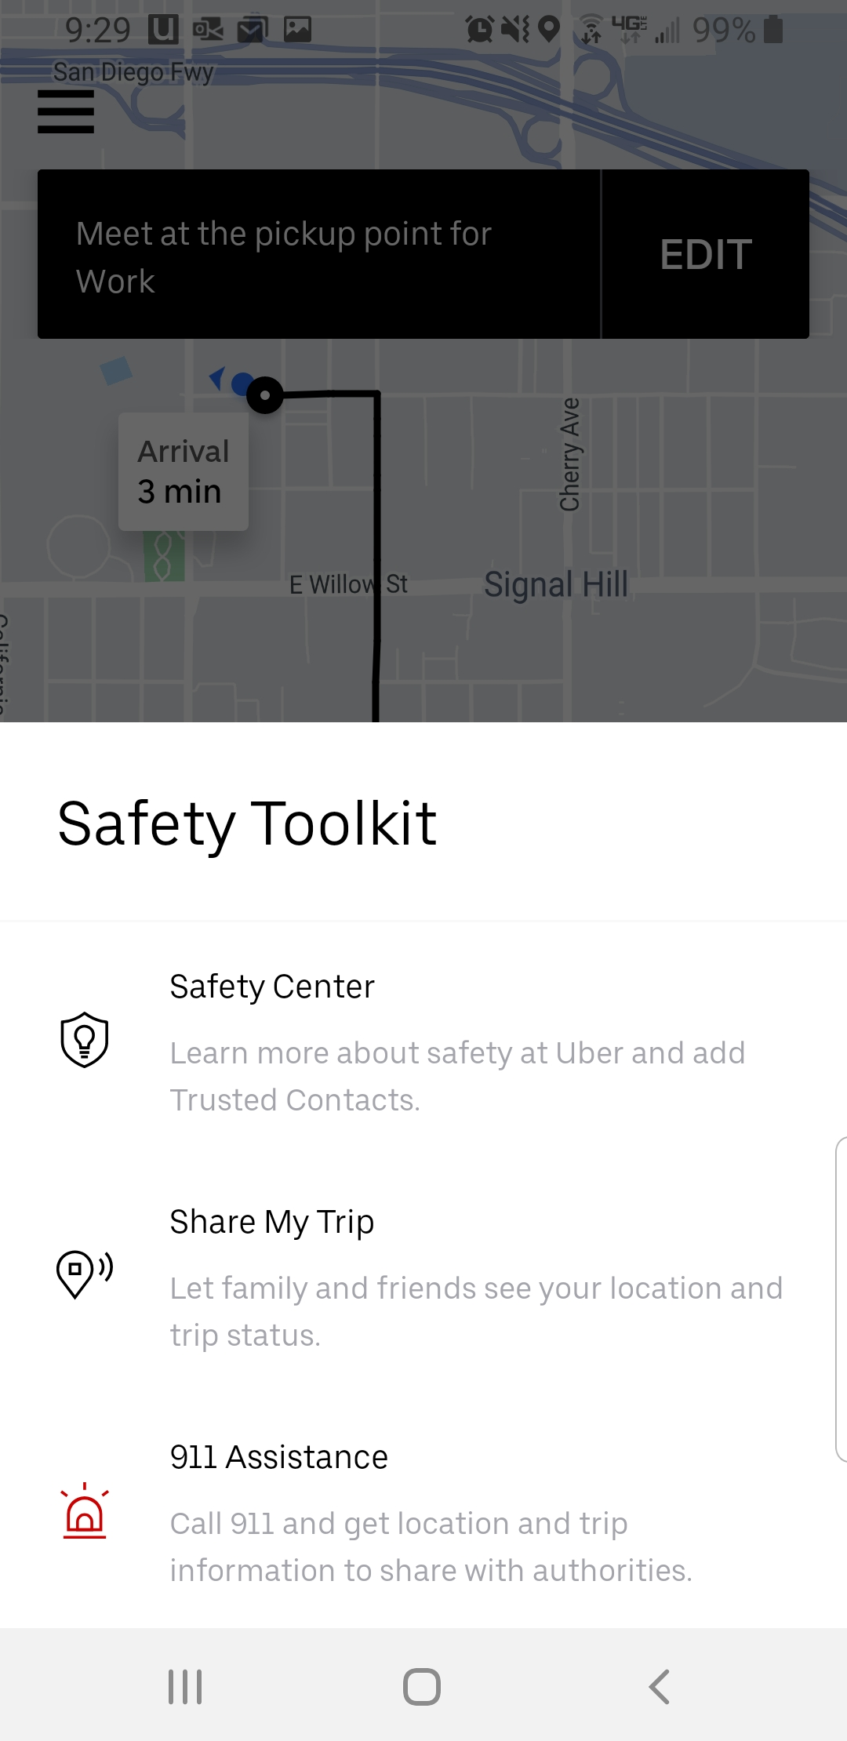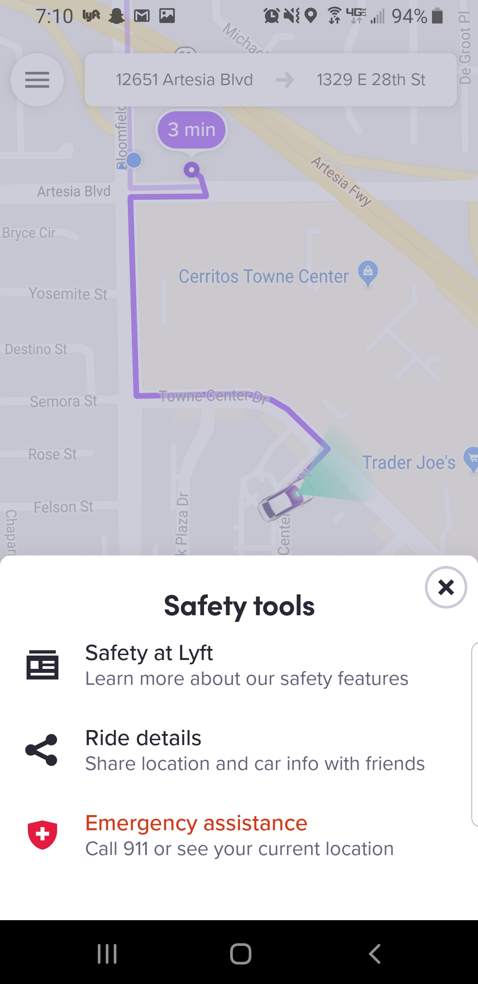

*Figure 2*. App screens in the Uber (Left, Center), and Lyft app (Right). The Uber screen (Left) displays ride information in the bottom panel as well as a map with your location and your drivers location above. When the blue shield icon is tapped the safety toolkit opens (Center). The Lyft app (Right) uses similar design elements for its safety information sections as well.

These three principles, in conjunction, can be effective ways to convey information to the rider. By grouping the vehicle information, driver information and trip information into distinct groups, we expect the rider to understand that the groups are separate but important.

Where these principles can be adapted to further optimize information transfer is in their contrast. The Uber and Lyft apps currently utilize the similarity, proximity, and common region principles to establish distinct groups that appear indistinct from each other. While the information within each group is unique and of value to the rider, the groups themselves, from a perceptual-level observation, appear to be the same. The same principle used to separate the information can also be applied to further separate the information groups. By bordering each group with a different color, for example, the groups now contain unique information and appear unique themselves. Furthermore, by displaying the information in slightly different formatting within the groups would allow for greater group contrast. Finally, each information panel could be brought into view by swiping from a different direction, the information and the groups themselves would become more salient by following the common fate principle.

**QR Code, Applications for Safety**

Implementation of a QR Code system will enhance security measures to Rideshare apps. The main problem with the current system is the informal way in which rides are verified; as it is often done by reciting the driver’s name shown in the app and hoping they will nod with a “yes”. Besides, the verification process is often skipped altogether, which shows the high amount of trust riders have in the service, but also raises huge security concerns for both parties. Therefore, the goal of this system is to address safety, while still delivering a fast and intuitive service people enjoy.

The first step to implementing this system is to create a unique QR code for each active driver listed in the rideshare platform. The QR code links to their personal account and is used as the code riders need to verify before getting into the vehicle. Since the system relies on scanning, it is necessary for the rider to have a functioning camera phone. From the driver’s side, a physical copy of the QR code will be visibly displayed on the passenger windows. The rest of the verification will be done within the app itself.

As the rider comes up close to the passenger door, they will use their camera to scan the code before entering the vehicle. If the scanned code is verified to the correct driver, then the app will display a confirmation message in green. In addition, a tone will accompany the confirmation. The multisensory feedback is done not only for convenience, but also to encourage multisensory encoding, which enables the person to encode and recall the information, even if it is later reproduced as unisensory cues (Thelen & Murray, 2013; Tulving & Thomas, 1973)

The multisensory security notification system is also used when the code cannot be verified. In this case, the notification will be displayed in red, and the tone will be different and the phone would vibrate for a moment. The saliency of the vibration feedback is especially important, since it makes it hard for a person to ignore and it is easy to recall (Tulving & Thomas, 1973). The power of salient cues is significant in that they facilitate recall even if their validity is questionable (Platzer & Broder, 2012). The cues utilized must be salient, since all efforts must be made to alert riders before they get into the wrong vehicle.The importance of including the multisensory and salient cues lies at the heart of SA, and subsequent memory processes (Tulving & Thomas, 1973). If the code can not be verified, the rider will need to use the secondary methods provided by the app. Finally, once the code has been correctly verified by the rider, the driver will also receive a notification confirming that the rider has been verified.

The system is designed to be simple and quick, with low intrusion to the app itself. Also, this is an optional step when using the rideshare app, and is not necessary to access the vehicle. However, even if not used, the fact that the company offers the service should be enough to increase user confidence in the service and put it at an advantage over other apps.

**Failsafe, the Safety Toolkit**

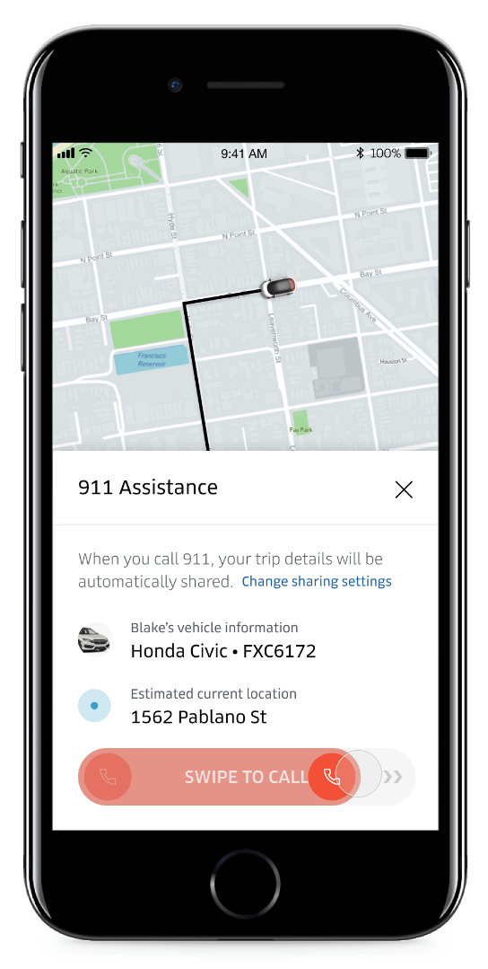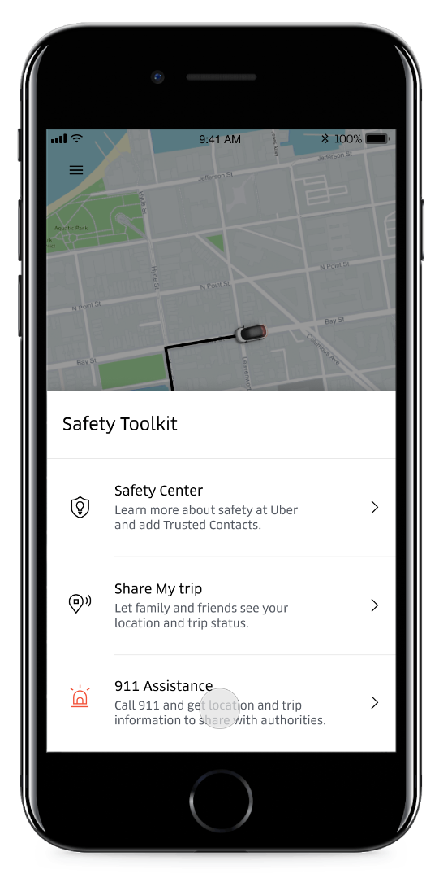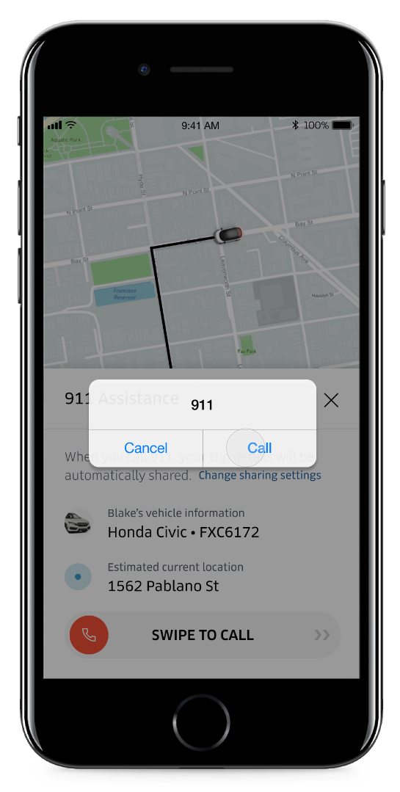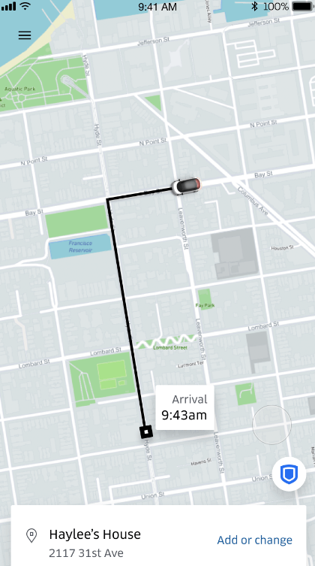In May 2018, Uber implemented the “safety toolkit” to increase the safety of its riders. This safety toolkit currently appears as a blue shield icon in the bottom right of the Uber home screen. When tapped, there are options to either access the safety center, share trip details with trusted contacts, or call 911. The current steps to access 911 assistance within the app are showcased in Figure 3.

*Figure 3.* In order to request 911 assistance, the rider must first tap the blue shield icon in the lower right hand corner to access the safety toolkit. They will then tap the third option in the toolkit, which is “911 Assistance.” The rider must then swipe to the right on “Swipe to call,” and then tap “Call” to initiate the 911 call. Retrieved from Uber website: <https://www.uber.com/newsroom/emergencybutton/>

While it is useful that Uber has implemented this safety toolkit, improvements can be made in order to quickly receive help when needed.

In conjunction with the previously mentioned Gestalt principles, the shield icon should be changed from blue to red, which increases salience. The “swipe to call” can remain the same as it prevents the rider from accidentally calling 911, due to the need to move the finger over the screen of the device without breaking contact versus briefly touching the screen (Villamor, Willis, & Wroblewski, 2010). However, when presenting all of the options in the safety toolkit, the order should be changed to reflect which options are most important in the context of receiving help. Following the serial-position effect (Murdock, 1962), “Safety center” should be in the middle, as it is the least important of the three options presented. The safety center is more of an informational resource, providing details on how Uber is working to improve safety for the rider as well as safety tips, which can be read at the leisure of the rider. The new order of the options will be “Share My Trip,” “Safety Center,” and “911 Assistance.”

The “911 Assistance” option in the safety toolkit can be made more salient to ensure attention is brought to this feature when needed (Endsley & Jones, 2011). Increasing salience will facilitate the decision making process when the rider has to choose between the options in the toolkit (Kaplan & Simon, 1990). The red siren outline can be changed to a solid siren icon in order to better capture attention while simultaneously distinguishing 911 assistance from the other options in the toolkit. Having a bright red icon that is also clearly a siren utilizes color redundancy (“Redundant coding”, n.d.) and improves accessibility for the app, as color-deficient users are slower in identifying a red light than users with regular color vision (Atchison, Pedersen, Dain, & Wood, 2003). The elderly population also has more trouble reaching icons in the lower right hand corner (Xiong & Muraki, 2016), and combined with the Nielsen Group discovering that users pay more attention to the left side when web browsing (Fessenden, 2017), moving the safety toolkit icon to the left may increase both SA and accessibility. However, designers also must ensure icons are not placed within one millimeter of the screen edge, as this is where most accidental touches occur (Matero & Colley, 2012). Being careful regarding icon placement can prevent riders from accidentally opening the safety toolkit and calling 911.

**Discussion and Conclusion**

In the design of apps involving interpersonal contact, such as with Uber or Lyft, promotion of SA is a necessity for the safety of all parties involved. Proper application of the principles of human factors can facilitate the development of SA of the driver and riders utilizing the app. The current versions of the mobile apps reviewed in this paper, and others apps not reviewed, can benefit from designing an app informed by human factors, as it would increase trust, usability and efficacy of the product.

Updating the apps to provide information to riders in a way that the important information is properly chunked and is presented either as the first bit or last bit in a string of serial information, in line with recency and primacy effects and the interaction of transience and persistence, ensures that individuals will retain the most important information presented to them. Utilizing the Gestalt Principles to form distinct groups of information that contrast with one another can further propagate the effects of information retention.

Utilization of a QR code to minimize rider-driver uncertainty, independent of all other recommended changes, would undoubtedly be a major contributor to SA that is also independent from many rider-driver disabilities such as deafness. Incorporating a QR code that a rider can scan requires no physical interaction between riders and drivers but allows them both to verify that they are in the vehicle with the person intended. The QR code also reduces the ability for malevolent acts from non involved individuals by making it difficult for false-drivers or riders to fake their identity, thus reducing the likelihood of negative events occurring.

Implementing changes to the safety toolkit in order to better bring attention to certain features improves the chances of the rider receiving help quickly. These changes include moving the safety toolkit icon to the left in order to better capture attention from riders according to their horizontal attention patterns, as well as making the icon easier to tap for older populations who have limited thumb movement. The order of the options in the safety toolkit should also be changed so that the most important information is more prominent, and the icon associated with the 911 assistance should be changed to a solid siren rather than a siren outline to increase the salience of the feature when needed.

Through app design informed by human factors, there is an expectation of certain design impacts. Utilizing the factors discussed above could increase user trust, leading to greater use of the product from current users in conjunction with new or returning users. Along with trust of the product to keep users returning, comes better usability of the product within in-app UI interactions as well as the physical interactions facilitated by the app. The increase in usability would allow for a greater number of users to use the app effectively. The increase in usability/accessibility could also make it easier for special populations, such as disabled persons or the elderly, to use the app. In conjunction with trust and usability we would expect an increase of product efficacy. If users trust the product, want to use the product and understand how to operate the product, the users should almost always produce the intended result.

A future area to explore would be personal identity verification (PIV). With the Uber app, the rider has the option of verifying their ride through either the car (e.g. model, license plate) or the driver (e.g. matching face to profile picture). However, the final identity verification is done verbally for both riders and drivers. In the future, PIV in the Uber app can be done through more secure means, such as biometrics. In addition, within the realm of interpersonal contact being facilitated by mobile apps, apps such as food or task delivery services (e.g. Postmates, Tinder) could also use similar principles their app design to facilitate efficient information transfer for their users.

There are limitations of the recommendations discussed. We only reviewed two apps, whereas there are other apps that could benefit from similar changes. Additionally, the apps were examined on both Android and iOS operating systems (OS), and therefore the appearance and functions apps may differ depending on the OS and device.

When designing mobile apps that require certain levels of physical personal interaction a human factors-based design approach is necessary to ensure user safety and app efficacy. The human factors principles discussed above can be utilized as key components in future iterations of app design.

Author Biographies:



Gregory Mather is a student in the Master of Human Factors program at California State University - Long Beach. He obtained his Bachelor of Science in Psychology at James Madison University. Primary fields of interest include; Usability and Design considerations for special populations, gamification, and cognitive load during visual tracking tasks. Gregory can be reached at [gregory.mather@student.csulb.edu](mailto:gregory.mather@student.csulb.edu).



Todd Roescher is a Masters student in the Human Factors program at the California State University at Long Beach. He currently holds a Bachelor of Science degree in Biomedical Engineering from Drexel University and works as a research engineer at Biomechanical Research and Testing. His research interests include perception-reaction, emergency response and situational awareness. Todd can be reached at [todd.roescher@student.csulb.edu](mailto:todd.roescher@student.csulb.edu)



Uyen Bui is a student in the Master of Science in Human Factors program at California State University, Long Beach (CSULB). She received her Bachelor of Arts in Psychology at CSULB. Her research interests currently lie in the areas of human-computer interaction, usability, user experience and user interface. Uyen can be reached at [uyen.bui@student.csulb.edu](mailto:uyen.bui@student.csulb.edu).



David Hermoza is a Masters student in the Human Factors program at California State University, Long Beach. He obtained his Bachelors of Science in Cognitive Science at the University of California, San Diego. His primary fields of interest include empathy, human-computer interaction, user-experience, product design, mixed reality. David can be reached at [david.hermoza@student.csulb.edu](mailto:david.hermoza@student.csulb.edu)

References

Atchison, D.A., Pedersen, C.A., Dain, S.J., & Wood, J.M. (2003). Traffic signal color recognition is a problem for both protan and deutan color-vision deficiency. *Human Factors: The Journal of the Human Factors and Ergonomics Society*, *45*(3), 495–503. doi: 10.1518/hfes.45.3.495.27247

Bolstad, C., Costello, A., & Endsley, M.R. (2006). Bad situation awareness designs: What went wrong and why.

Company Information: Uber Newsroom United Kingdom. (2019, January 12). Retrieved November 20, 2019, from <https://www.uber.com/en-GB/newsroom/company-info/>.

Ebbinghaus, H. (1885). Memory: A Contribution to Experimental Psychology. 1913, doi:10.1037/10011-000.

Endsley, M.R. (1988). Situation awareness global assessment technique (SAGAT). *Proceedings of the National Aerospace and Electronics Conference*, 789–795. doi: 10.1109/naecon.1988.195097

Endsley, M.R., Bolte, B., & Jones, D.G. (2011). *Designing for situation awareness: an approach to user-centered design* (2nd ed.). Boca Raton, FL: CRC Press.

Fessenden, T. (2017, October 22). Horizontal attention leans left. Retrieved November 27, 2019, from <https://www.nngroup.com/articles/horizontal-attention-leans-left/>.

Hall, J.D., Palsson, C., & Price, J. (2018). Is Uber a substitute or complement for public transit? Journal of Urban Economics, 108, 36–50. doi: 10.1016/j.jue.2018.09.003

Kaplan, C.A., & Simon, H.A. (1990). In search of insight. *Cognitive Psychology*, *22*(3), 374–419. doi: 10.1016/0010-0285(90)90008-r

Koffka, K. (1935). Principles of Gestalt psychology. Harcourt, Brace.

Matero, J., & Colley, A. (2012). Identifying unintentional touches on handheld touch screen devices. *Proceedings of the Designing Interactive Systems Conference on - DIS 12*. doi: 10.1145/2317956.2318031

Murdock, B.B. (1962). The serial position effect of free recall. *Journal of Experimental Psychology*, *64*(5), 482–488. doi: 10.1037/h0045106

Pew Research Center. (January 4, 2019). Percentage of respondents in the United States using ride sharing apps in 2015 and 2018 [Graph]. In Statista. Retrieved November 20, 2019, from-https://www.statista.com/statistics/822877/consumers-who-use-ride-sharing-united-states/

Platzer, C., & Bröder, A. (2012). Most people do not ignore salient invalid cues in memory-based decisions. Psychonomic Bulletin & Review, 19(4), 654-661. doi:10.3758/s13423-012-0248-4

Redundant coding. (n.d.). Retrieved December 5, 2019, from <https://www.hf.faa.gov/webtraining/visualdisplays/Color/RedundantCoding3.htm>.

Richards, B.A., & Frankland, P.W. (2017). The Persistence and Transience of Memory. Neuron, 94(6), 1071–1084. doi: 10.1016/j.neuron.2017.04.037

SharesPost. (January 18, 2017). How frequently do you use Uber? [Graph]. In Statista. Retrieved November 20, 2019, from https://www.statista.com/statistics/823533/frequency-of-uber-usage-us/

She thought it was her Uber. Student got into wrong car and was killed, police say. (2019, April 1). Retrieved from <https://www.latimes.com/nation/nationnow/la-na-south-carolina-college-student-20190331-story.html>

Spears, D. (2018, November 21). Woman escapes from fake Uber driver. Retrieved from https://www.ktnv.com/news/contact-13/rideshare-nightmare-woman-jumped-from-car-to-escape-fake-uber-driver

Tan, L., & Ward, G. (2000). A recency-based account of the primacy effect in free recall. *Journal of Experimental Psychology: Learning, Memory, and Cognition, 26*(6), 1589-1625.

Thalmann, M., Souza, A.S., & Oberauer, K. (2019). Revisiting the attentional demands of rehearsal in working-memory tasks. Journal of Memory and Language, 105, 1-18. doi:10.1016/j.jml.2018.10.005

Thelen, A., & Murray, M.M. (2013). The Efficacy of Single-Trial Multisensory Memories. Multisensory Research, 26(5), 483-502. doi:10.1163/22134808-00002426

Tulving, E., & Thomson, D. (1973). Encoding specificity and retrieval processes in episodic memory. Psychological Review, 80, 352–372.

Uber (2019). 2017-2018 US safety report [PDF]. Retrieved from

<https://www.uber-assets.com/image/upload/v1575580686/Documents/Safety/UberUSSafetyReport_201718_FullReport.pdf>.

Villamor, C., Willis, D., & Wroblewski, L. (2010). Touch gesture reference guide [PDF]. Retrieved from <https://static.lukew.com/TouchGestureGuide.pdf>.

Xiong, J., & Muraki, S. (2016). Effects of age, thumb length and screen size on thumb movement coverage on smartphone touchscreens. *International Journal of Industrial Ergonomics*, *53*, 140–148. doi: 10.1016/j.ergon.2015.11.004